Put the letters in order and draw the PARTS OF THE BODY
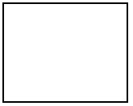

GRENFI ________ DNAH __________ AEDH __________ TEEF ___________

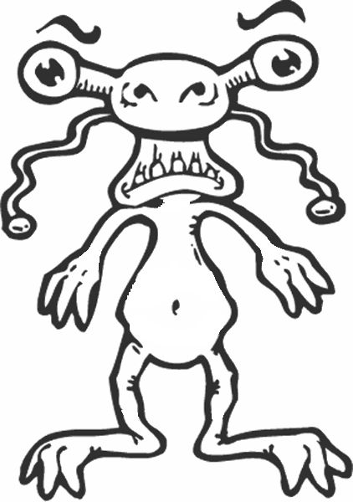
ETO ___________ GLE __________ RAM ___________ OOFT ___________

Now look at the monster and colour the parts of the body. Then write.

-ARMS: red
-FINGERS : orange
-HEAD: purple
-TEETH: green
-LEGS: yellow
-TOES: blue
-FEET: brown
-EYES: grey
-HANDS: black

